Functional Specification Document

Redesign of Lab Imaging

R25LIS

1.0

Vidisha Dixit

01/09/2025

Table of Contents
Sr. No. | Name | Page No.
1. | Document Revisions | 3
2. | Approvals | 3
3. | RACI Chart for This Document | 4
4. | Introduction | 5
4.1. | Business Goals | 9
4.2. | Business Objectives | 5
4.3. | Business Rules | 6
4.4. | Background | 6
4.5. | Project Objective | 7
4.6. | Project Scope | 8
4.6.1. | In Scope Functionality | 8
4.6.2. | Out Scope Functionality | 9
5. | Assumptions | 10
6. | Constraints | 11
7. | Risks: Technological Risks, Skills Risks, Political Risks, Business Risks, Requirements Risks, Other Risks | 11
8. | Business Process Overview | 13
8.1. | Legacy System (AS-IS) | 14
8.2. | Proposed Recommendations (TO-BE) | 15
9. | Business Requirements | 16
10. | Appendices | 16
10.1. | List of Acronyms | 16
10.2. | Glossary of Terms | 16
10.3. | Related Documents | 16

Version Control
Date | Version Number | Document Changes
21/08/2025 | 0.1 | Initial Draft
26/08/2025 | 0.2 | Section 2 (page no 43, 44)
29/08/2025 | 0.3 | Section 3 (page no 58)
01/09/2025 | 1.0 | Sign off

Approvals (Stakeholder List)
Role | Name | Title | Email Address / Phone Number | Date
Project Sponsor | M*** G**** | Sr VP | M*******@gmail.com | 1st Sign Off:  01-09-25  2nd Sign off:
Business Owner
Subject Matter Expert (SME)
Technical Team from client’s side
Implementation SME

RACI Matrix

Task / Activity | Business Analyst | Product Manager | Developers | QA Team | Compliance Team
Gather Requirements | R | A | I | I | C
Design System Architecture | C | A | R | I | C
Develop LIS Application | C | A | R | I | I
Integrate APIs | C | A | R | I | C
Implement Decision Logic | C | A | R | I | C
Compliance Review & Approval | C | I | I | I | R/A
Testing & Quality Assurance | C | A | C | R | I
Deployment to Production | I | A | R | C | I
Post-Deployment Monitoring | C | A | R | C | I

Legend:

R (Responsible) – Does the work to complete the task.
A (Accountable) – Ultimately answerable for correct completion.
C (Consulted) – Provides input, expertise.
I (Informed) – Kept up-to-date on progress.

Introduction
The Laboratory Workflow Improvement Project aims to streamline the laboratory team's workflow, reduce delays, and enhance stakeholder satisfaction. The project will focus on automating manual steps, integrating the Laboratory Information System (LIS) with downstream reporting systems, and providing real-time visibility into sample processing and report generation.

As-Is state
The AS-IS process describes how the laboratory workflow currently operates before improvements are implemented.

Current Challenges
- Manual sample status updates
- Duplicate data entry across systems
- Delayed report generation
- Limited visibility into sample progress
- Disconnected LIS and reporting systems
- Increased chances of human error

AS-IS Workflow – Laboratory Operations
Sample Collection
↓
Manual Sample Registration
↓
Is Sample Data Valid?
↙ ↘
No Yes
Correct Data Continue
↓
Lab Technician Updates Multiple Systems Manually
↓
Sample Testing Performed
↓
Manual QA Validation
↓
QA Validation Passed?
↙ ↘
No Yes
Retest/Rework Report Prepared Manually
↓
Report Uploaded Across Systems
↓
Stakeholders Check Status Through Emails/Calls

Flowchart
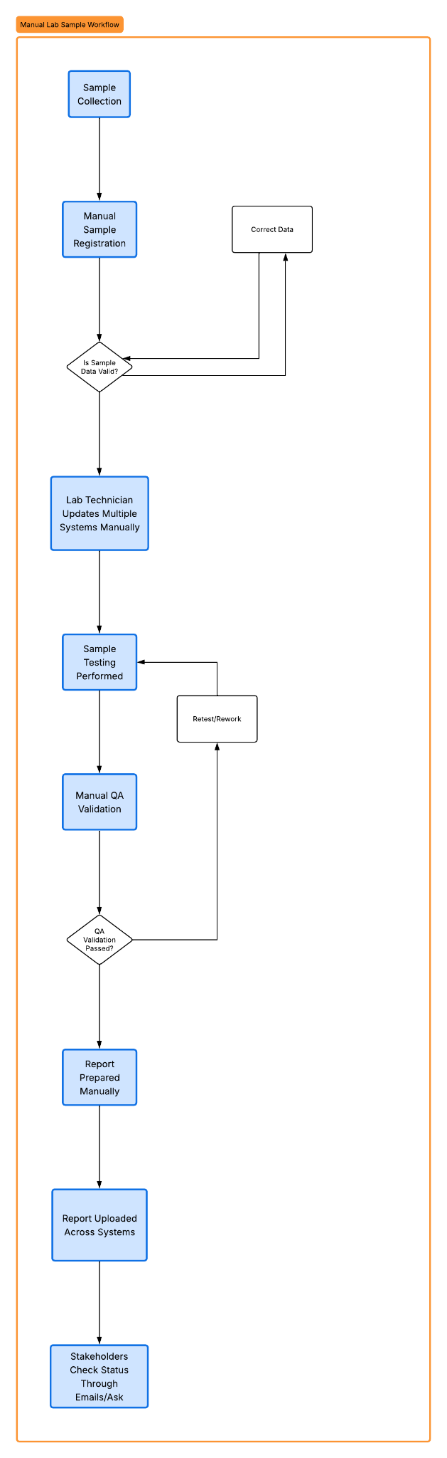

AS-IS Pain Points
Pain Point | Impact
Manual status updates | Delays and errors
Multiple disconnected systems | Duplicate work
No real-time visibility | Stakeholder frustration
Manual report generation | Slow turnaround time
Inconsistent data across systems | Operational inefficiencies

TO-BE Process (Future State)
The TO-BE process describes the improved workflow after automation and integration are implemented.

Expected Improvements
- Automated sample status synchronization
- Integrated LIS and reporting systems
- Real-time sample tracking
- Faster report generation
- Reduced manual intervention
- Better stakeholder visibility

TO-BE Workflow – Laboratory Operations
Sample Collection
↓
Automated Sample Registration in LIS
↓
Sample Data Valid?
↙ ↘
No Yes
Exception Queue Continue Workflow
/Correction ↓
Automatic Status Synchronization Across Systems
↓
Sample Testing Performed
↓
Automated Workflow Notification to QA
↓
Digital QA Validation
↓
QA Validation Passed?
↙ ↘
No Yes
Retest/Rework Automated Report Generation
↓
Real-Time Report Availability to Stakeholders

Flowchart

TO-BE Benefits
Improvement | Business Benefit
Automated updates | Reduced manual effort
System integration | Improved data consistency
Real-time tracking | Better operational visibility
Automated reporting | Faster turnaround time
Reduced human dependency | Lower error rates

Business Goal(SMART method)

Reduce Sample Processing Time
Reduce average laboratory sample processing time by 30% within 6 months of implementation through workflow automation and system integration.

Improve Report Generation Turnaround Time
Decrease laboratory report generation turnaround time by 25% within 4 months by automating report creation and reducing manual intervention.

Reduce Manual Data Entry Errors
Reduce manual data entry and duplicate update errors by 40% within 3 months through automated status synchronization across integrated systems.

Improve Real-Time Workflow Visibility
Provide real-time sample tracking visibility to 95% of authorized stakeholders within the first phase of deployment.

Increase Operational Efficiency
Improve laboratory operational efficiency by minimizing redundant workflow steps and reducing manual handoffs across systems within 6 months.

Scope Description

In Scope
- Automation of sample status updates across laboratory systems
- Integration between Laboratory Information System (LIS) and downstream reporting applications
- Real-time sample tracking visibility for authorized stakeholders
- Automated report generation upon completion of sample processing
- Workflow analysis and process optimization for laboratory operations
- User training and UAT support
- Migration of historical sample data from legacy systems

Use case
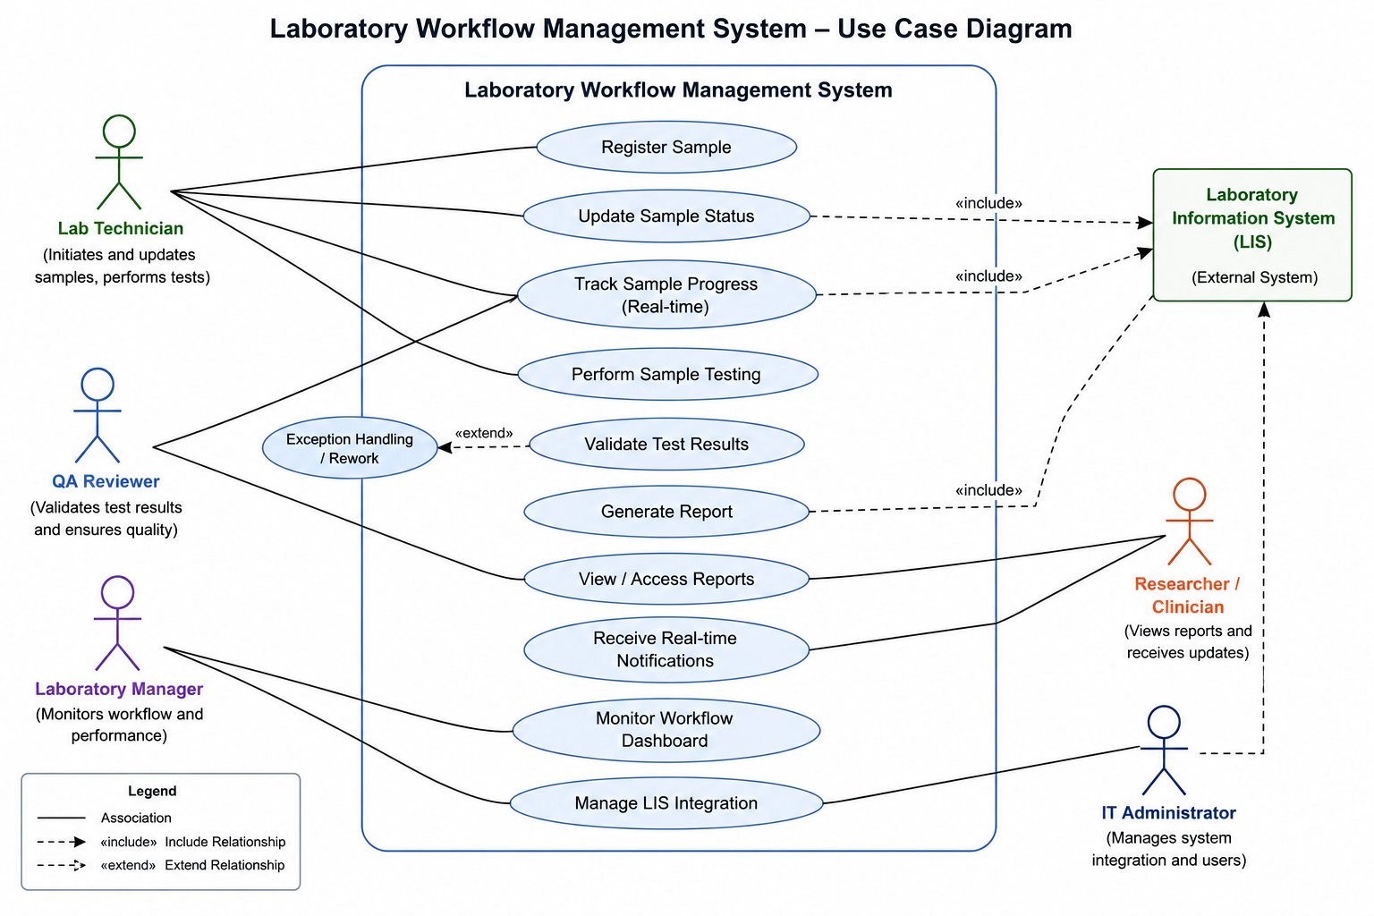

DFD
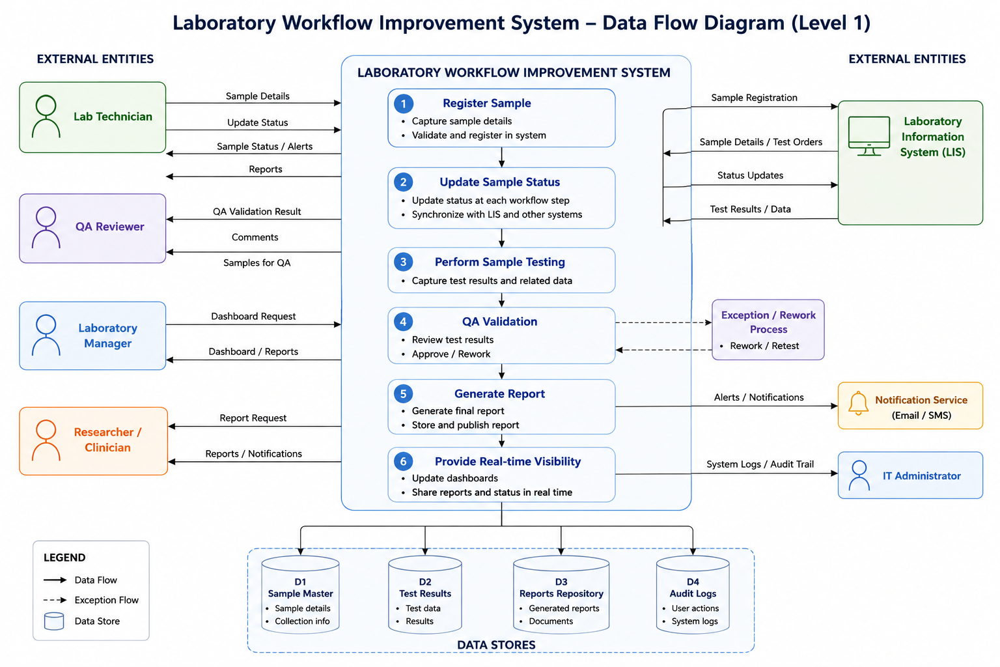

Out of Scope
- Replacement of the existing Laboratory Information System (LIS)
- Hardware procurement or laboratory equipment upgrades
- Changes to laboratory testing methodologies or medical procedures
- Regulatory policy changes outside current compliance requirements
- Integration with external third-party healthcare providers not identified in the project scope

RAID log

No. | RAID Category | Description | Impact | Owner | Priority
R-001 | Risk | Data Migration Risk | Historical laboratory data may be incomplete or inconsistent during migration from legacy systems. | IT Department / Data Migration Team | High
R-002 | Risk | Integration Failure Risk | Integration issues between LIS and downstream systems may impact real-time data synchronization. | Integration Team / Solution Architect | High
R-003 | Risk | User Adoption Resistance | Laboratory staff may resist transitioning from existing manual workflows. | Change Management Team / Project Manager | Medium
R-004 | Risk | Downtime During Deployment | Unexpected downtime during implementation may disrupt laboratory operations. | Infrastructure Team / IT Operations | High
I-001 | Issues | Inconsistent Sample Status Updates | Different systems currently maintain inconsistent sample statuses, causing confusion and delays. | Laboratory Operations Team | High
I-002 | Issues | Duplicate Data Entry | Lab technicians are required to update multiple systems, increasing workload and error rates manually. | Laboratory Operations Team | High
I-003 | Issues | Delayed Report Availability | Report generation delays impact researchers and operational stakeholders. | Reporting Team / Laboratory Management | High
I-004 | Issues | Limited Workflow Visibility | Stakeholders lack centralized visibility into sample processing stages and report completion status. | Laboratory Management | Medium
D-001 | Dependencies | Availability of LIS APIs or Integration Support | Successful integration depends on access to LIS integration capabilities and technical documentation. | LIS Vendor / Integration Team | High
D-002 | Dependencies | Stakeholder Availability | Requirement gathering and UAT activities depend on availability of laboratory SMEs and operational users. | Business Stakeholders / Project Manager | Medium
D-003 | Dependencies | Infrastructure Readiness | Cloud and server environments must be provisioned before deployment and integration testing. | Infrastructure / Cloud Team | High
D-004 | Dependencies | Data Migration Readiness | Legacy system data must be cleansed and validated prior to migration activities. | Data Migration Team | High
A-001 | Assumptions | Multiple Systems Usage | The laboratory team uses multiple systems for sample processing and report generation. | Business Analyst | Medium
A-002 | Assumptions | LIS as Primary System | The Laboratory Information System (LIS) is the primary system used for managing sample data. | Laboratory Management | High
A-003 | Assumptions | Stakeholder Identification | Stakeholders include lab technicians, researchers, and potentially external parties such as patients or regulatory bodies. | Project Sponsor | Medium
A-004 | Assumptions | Manual Process Errors | The current manual processes are prone to human error, contributing to delays and inefficiencies. | Business Analyst / Operations Team | High
A-005 | Assumptions | Role-Based Access Availability | Authorized stakeholders will have role-based access to sample tracking and reporting information. | Security / IT Team | High
A-006 | Assumptions | Existing System Integration Capability | Existing systems support integration capabilities required for workflow automation. | Solution Architect / IT Team | High
A-007 | Assumptions | User Participation in UAT and Training | Laboratory staff will participate in training and UAT activities. | Laboratory Management | Medium
A-008 | Assumptions | Compliance and Security Approval | Required compliance and security approvals will be obtained before production deployment. | Compliance Team / Security Team | High

Constraints
Project constraints are limitations that the project faces due to funding, scheduling/time, technology, or resources. Constraints may also be physical (i.e. inadequate space or facilities). Constraints must be carefully planned for and communicated to all stakeholders as they may require an elevated level of urgency or flexibility to work within and successfully complete the project. This section of the project scope statement template describes the project’s constraints to ensure that all stakeholders understand the limitations within which the project must be completed.

Release Plan

Release Phase | Duration | Objective
Phase 1 – Foundation & Integration Setup | Week 1–2 | Environment setup, LIS integration, initial workflow configuration
Phase 2 – Core Workflow Automation | Week 3–4 | Automated sample registration and status synchronization
Phase 3 – QA & Reporting Enablement | Week 5 | Digital QA validation and automated report generation
Phase 4 – Real-Time Visibility & UAT | Week 6 | Dashboard visibility, stakeholder validation, and UAT
Phase 5 – Production Deployment & Hypercare | Week 7 | Go-live support, monitoring, issue resolution

